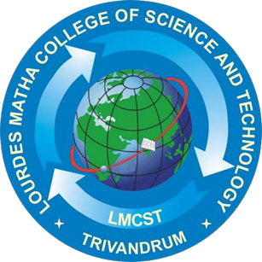

A PROJECT REPORT

Submitted by:

**LEKSHMI S R**

**LLMC17MCA020**

to

*The APJ Abdul Kalam Technological University*

*in partial fulfillment of the requirements for the award of the Degree*

*of*

*Master of Computer Applications*

**A SECURE IoT BASED MODERN HEALTHCARE SYSTEM USING BODY SENSOR NETWORK**

**Department of Computer Applications**

LOURDES MATHA COLLEGE OF SCIENCE AND TECHNOLOGY

KUTTICHAL, THIRUVANANTHAPURAM 695574

MAY 2020

**A SECURE IoT BASED MODERN HEALTHCARE SYSTEM USING BODY SENSOR NETWORK**

A PROJECT REPORT

Submitted by:

**LEKSHMI S R**

**LLMC17MCA020**

to

*The APJ Abdul Kalam Technological University*

*in partial fulfillment of the requirements for the award of the Degree*

*of*

*Master of Computer Applications*

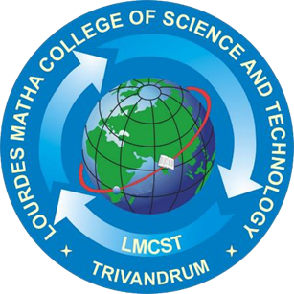

**Department of Computer Applications**

LOURDES MATHA COLLEGE OF SCIENCE AND TECHNOLOGY

KUTTICHAL, THIRUVANANTHAPURAM 695574

MAY 2020

**DEPARTMENT OF COMPUTER APPLICATIONS**

**LOURDES MATHA COLLEGE OF SCIENCE AND TECHNOLOGY KUTTICHAL, THIRUVANANTHAPURAM**

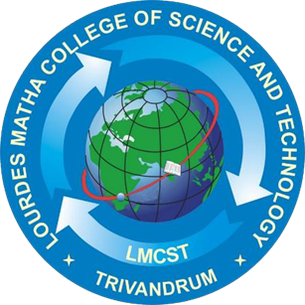

## CERTIFICATE

This is to certify that the report entitled **‘A SECURE IoT BASED MODERN HEALTHCARE SYSTEM USING BODY SENSOR NETWORK’** submitted by **LEKSHMI S R** to the APJ Abdul Kalam Technological University in partial fulfilment of the requirements for the award of the Degree of Master of Computer Applications is a Bonafede record of the project work carried out by him under my guidance and supervision.

Prof. Anjana J

(Internal Supervisor)

Prof. Justin G Russel Prof.Selma Joseph

(Project Co-ordinator) (Head of the Dept.)

## DECLARATION

I undersigned hereby declare that the project report ‘A Secure IoT Based Modern Healthcare System Using Body Sensor Network’, submitted for partial fulfilment of the requirements for the award of degree of Master of Computer Applications of the APJ Abdul Kalam Technological University, Kerala is a Bonafede work done by me under supervision of Prof. Anjana J. This submission represents my ideas in my own words and, I have adequately and accurately cited and referenced the original sources. I also declare that I have adhered to ethics of academic honesty and integrity and have not misrepresented or fabricated any data or idea or fact or source in my submission. I understand that any violation of the above will be a cause for disciplinary action by the institute and/or the University.

Place: Trivandrum Signature

Date: 14/06/2020Lekshmi S R

**ACKNOWLEDGEMENT**

At the outset I like to mention that a project report of this magnitude could not have been possible to make without the support, assistance and guidance of some distinguished personalities.

I am greatly indebted to all those who helped and guided me to make this report without which it would not have been possible for me to do this work.

First of all, I like to express my sincere thanks to **Rev.Dr.. Tomy Joseph Padinjareveetil**, Director of Lourdes Matha College of Science and Technology and our principle **Prof. Dr. Mohanlal PP** for granting permission to do this project and giving necessary guidance and assistance.

**Prof. Anjana J** has always been at her best to help me to the right path which was a great factor of encouragement.

I like to extend my sincere gratitude to **Prof.Selma Joseph, Head** Of the department of Computer Application. she was always approachable and gave correct advice to go ahead with the project

Let me also take this opportunity to extend gratitude to our esteemed institution Lourdes Matha College of Science and Technology.

My parents who held my hand throughout in my endeavour to do this project need a special mention.

I also like to thank my friends who helped me abundantly in the successful completion of this project report.

Any omission in acknowledgement may be pardoned as it is not intentional.

**TABLE OF CONTENT**

|  |  |
| --- | --- |
| **TITLE** | **PAGE NO:** |
| **ACKNOWLEDGEMENT** | **1** |
| **ABSTRACT** | **2** |
| **Chapter 1 INTRODUCTION** | **3** |
| 1 .1 General Background | 3 |
| 1.2 Objectives | 4 |
| **Chapter 2 LITERATURE SURVEY** | **5** |
| 2.1 Study of similar work | 5 |
| 2.1.1 Existing System | 7 |
| 2.1.2 Drawbacks of Existing system | 7 |
| **Chapter 3 OVERALL DESCRIPTION** | **8** |
| 3.1 Proposed System | 8 |
| 3.2 Features of Proposed System | 9 |
| 3.3 Functions of Proposed System | 10 |
| 3.4 Requirement Specification | 10 |
| 3.5 Feasibility Analysis | 11 |
| 3.5.1 Technical Feasibility | 11 |
| 3.5.2 Operational Feasibility | 12 |
| 3.5.3 Economical Feasibility | 12 |
| 3.5.4 Behavioral Feasibility | 12 |
| **Chapter 4 OPERATING ENVIRONMENT** | **13** |
| 4.1 Hardware Requirements | 13 |
| 4.2 Software Requirements | 13 |
| 4.3 Tools and Platforms | 14 |
| 4.3.1 Arduino IDE | 15 |
| 4.3.2 Embedded C | 15 |
| 4.3.3 Thingspeak | 15 |
| 4.3.4 Iot | 15 |
| 4.3.5 Thingspeak Features | 15 |
| 4.3.6 Blynk Server | 16 |
| 4.3.7 LM35 Temperature Sensor | 16 |
| 4.3.8 Heart Rate Sensor | 16 |
| 4.3.9 Windows 10 | 16 |
| 4.3.10 Android Language | 16 |
| 4.3.11 NODE MCU | 17 |
| **Chapter 5 DESIGN** | **17** |
| 5.1 System Design | 17 |
| 5.1.1 Data Flow Diagram/UML | 17 |
| 5.1.1.1 Basic DFD Symbols | 18 |
| 5.1.1.2 components of DFD | 18 |
| 5.1.2 Project Data Flow Diagram / UML | 19 |
| 5.2 Database Design | 24 |
| 5.3 Input Design | 24 |
| 5.4 Output Design | 25 |
| 5.5 Program Design | 26 |
| **Chapter 6 FUNCTIONAL AND NON-FUNCTIONAL REQUIREMENTS** | **27** |
| 6.1 Functional Requirements | 27 |
| 6.2 Non-functional Requirements | 27 |
| **Chapter 7 TESTING** | **29** |
| 7.1 Testing Strategies | 29 |
| 7.2 Unit testing | 30 |
| 7.3 Integration Testing | 30 |
| 7.4 System Testing | 31 |
| 7.5 Testing Results | 32 |
| **Chapter 8 RESULTS AND DISCUSSION** | **33** |
| 8.1 Results | 33 |
| 8.2 Screen Shots | 34 |
| **Chapter 9 CONCLUSION** | **36** |
| 9.1 System Implementation | 36 |
| 9.2 Conclusion | 36 |
| 9.3 Future Enhancement | 37 |
| **REFERENCES/BIBLIOGRAPHY** | **38** |
| 1.Books | 38 |
| 2.Websites | 38 |
| **APPENDICES** | **39** |
| 1.SCRUM Model | 39 |
| 2.List of Tables | 41 |
| 3.List of Figures | 41 |
| 4.Abbreviations and Notations | 42 |
| 5.Coding | 43 |